**5/9/22**

Info:

I soldered a new end onto these two wires to be able to plug it into the board for the Ender printer. \

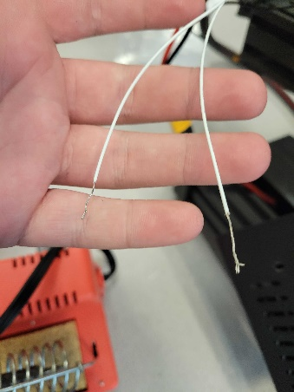 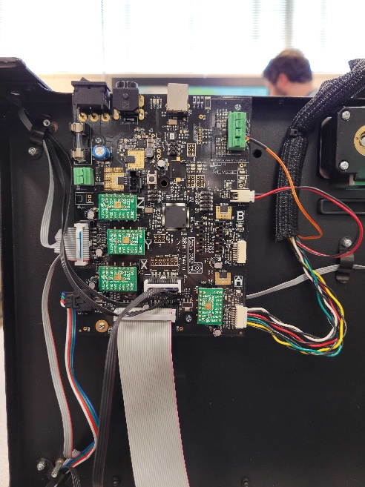

[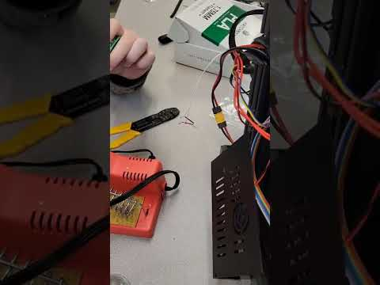](https://www.youtube.com/watch?v=gxrzR9mGz7U)